**COURSERA CAPSTONE PROJECT**

**INTRODUCTION/BUSINESS PROBLEM**

**The main objective of this project is to give a recommendation to the business to open a shopping mall in Chennai, India. Chennai is the capital city of TamilNadu, India. Its a very hot place and any business started in that city should be started with a proper insight of the area and the locations near by, for the business to be successful. So the main objective of this report is to provide insights of the Chennai City and help the stake holders decide on opening a Shopping Mall.**

**TARGET AUDIENCE FOR THIS PROJECT**

**The main target audiences of this project are investors who want to invest in opening a shopping mall in the City of Chennai,India.**

**DATA**

**To provide insights we use the following data.**

**\* List of neighbourhoods of Chennai City which confines to only Chennai City.(Source Wiki)**

**\* Lat and Long of Chennai City(which was fetched with geolocator)**

**\* Lat and Long of Chennai City which was already provided in the Wiki Page.**

**\* Venue Data relating to Shopping malls (fetched using Four Square API)**

**SOURCES OF DATA AND METHOD OF EXTRACTION**

**SOURCES:**

**\* Chennai Neighborhood data**

[https://en.wikipedia.org/wiki/List_of_neighbourhoods_of_Chennai](linkref:%20https://en.wikipedia.org/wiki/List_of_neighbourhoods_of_Chennai)

**\* Venue Data**

Foursquare API

**METHODOLOGY:**

* Use webscraping to scrap the Wiki website and get the data of Chennai Neighborhoods.

* Use Four Square API to get the Venues closer to the Chennai Neighborhoods.

* Analyse the Data returned by the Four Square API to group them into Clusters.

* Use K means Clustering to group the neighborhoods to Clusters

* Analyse which group of Clusters have less shopping malls

* Provide Recommendations for the Stake holders the clusters that ahs a potential to set up new malls.

* The project focusses on places with in radius 2000 and with a limit of 100 venues

**Chennai Map**

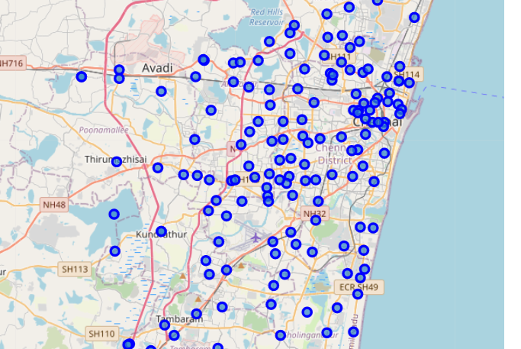

**After superimposing the clusters on to the Chennai map :**

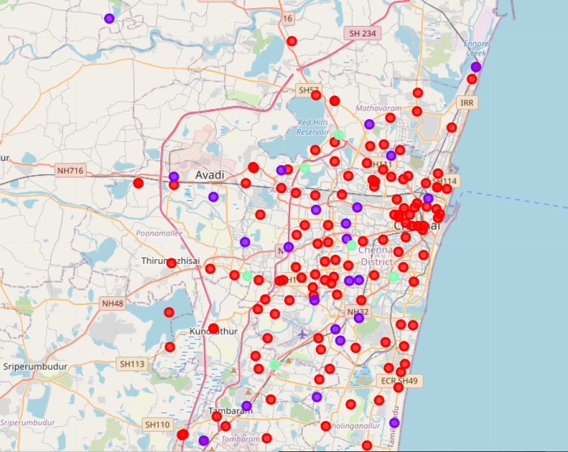

**RESULTS**

**The Chennai Neighborhood is divided into 3 clusters:**

**1)Cluster 0(Red)**

**2)Cluster1(Blue)**

**3)Cluster2(Light Green)**

**DISCUSSION**

**\* There are 132 neighborhoods in the Cluster 0 that has no shopping malls.**

**\* There are 26 shopping malls in the Cluster 1 that has one shopping mall per neighborhood**

**\* There are 17 shopping malls in Cluster 2.**

**CONCLUSION**

**The recommendation made:**

**Cluster 0 Zone is the best zone for investing on a shopping mall. As there are no shopping malls and Cluster 0 is the central part of the city. It would add to more revenue generations.**

**REFERENCES**

[https://en.wikipedia.org/wiki/List_of_neighbourhoods_of_Chennai](linkref:%20https://en.wikipedia.org/wiki/List_of_neighbourhoods_of_Chennai)

[Docs | Foursquare](https://developer.foursquare.com/docs/)